# ASD Virtual Program Enrollment Guide (Hmong)

## Pab cov niam txiv tso cov me nyuam rau hauv lub ASD Virtual Program siv ParentConnect.

**Daim ntawv qhia ib kauj ruam zuj zus**

Mus rau hauv [ParentConnect](http://parentconnect.asdk12.org/) ([parentconnect.asdk12.org](http://parentconnect.asdk12.org/))

* Yog ParentConnect tus PIN los sis password tsis paub, thov mus saib [this website](https://parentconnect.asdk12.org/Production/ParentPortal/Home/LoginReminder) mus hloov tus password. Thaum uas koj hloov koj password koj yuav tau ib tus PIN number uas yog xa rau koj tug email.
* Yog kog thov kev pab ntxiv hais txog nkag mus hauv ParentConnect, thov ua ib daim pib rau hauv ASD Parent/Student Support Portal nyob hauv [help.asdk12.org](http://help.asdk12.org), los sis hu rau 907-742-HELP.

Thaum koj nkag rau hauv ParentConnect, nyem qhov **My Information** nyob saum.

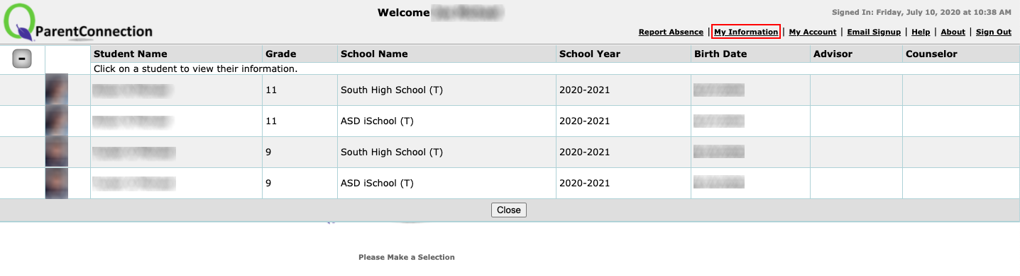

Nyob rau kab koj tus me nyuam kawm ntawv lub npe koj xav muab tso hauv ASD Virtual Program, nyem **Edit**.

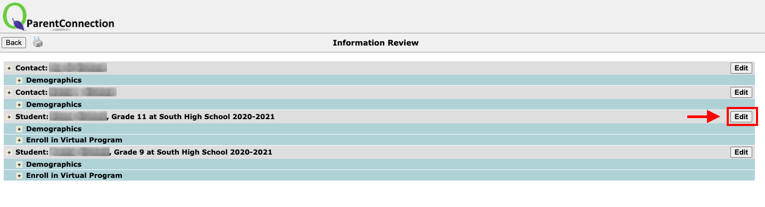

Nyob rau sab laug, nyem **Enroll In Virtual Program**.

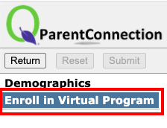

Txheeb xyuas cov lus hais no, ces nyem lub **Check Box** es yuav qhia tias koj xav tso koj tus me nyuam kawm ntawv rau hauv ASD Virtual Program.

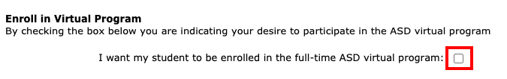

Nyob rau hauv kem **Student Device**, **Home Connectivity**, thiab **Other Program Participation**, xaiv qhov es zoo tshaj rau koj.

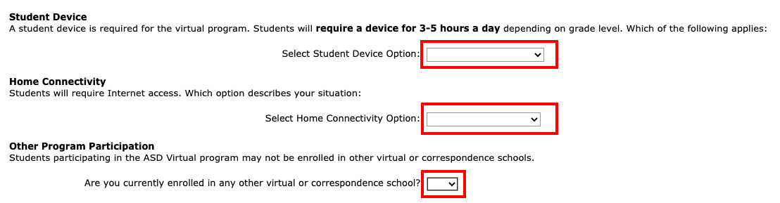

Thaum twg koj ua tas txhua yam, nyem **Submit** rau saum no. Koj yuav tsum nias **Submit** es koj cov koj uas no yuav raug khaws cia.

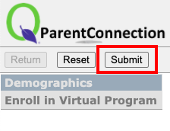

Thaum koj nias Submit nws yuav coj koj rov qab mus pib qhov **My Information**. Yog tias koj muaj tub ntxhais kawm ntxiv hauv ASD Virtual Program, rov ua cov kauj ruam 3 - 7 rau txhua tus tub ntxhais kawm.